E Taxpay
Multilingual Shop Tax Management System for Uttarakhand Zila Panchayat
A project Report submitted in partial fulfilment of the
requirements for the award of the diploma of
Computer Science
(POLYTECHNIC)
Submitted by
Sumit Bhandari (23060120015)
Manish Paliwal(23009050012)
Bhavesh Bisht (23009050004)
Raja Rautela (23009050018)
Lalit Singh Kanyal(23009050034)
Sahil Chand (23009050014)
Deepak Singh Bisht (23050050001)
Gaurav Bisht(23009050020)



Under the supervision of

Mr.Manmohan sir Mr.Virendra sir
Lecturer C.S.E Lecturer C.S.E
C.S.E Department C.S.E Department

DEPARTMENT OF COMPUTER SCIENCE

GOVT. POLYTECHNIC KASHIPUR
KASHIPUR –244713 (UTTARAKHAND) INDIA APRIL, 2026

Introduction
The E-TaxPay system is a digital platform designed to simplify and modernize the shop tax collection process for the Zila Panchayat in Uttarakhand. Traditionally, shop tax collection has been handled manually through paperwork and physical visits to government offices. This process often leads to delays, record mismanagement, lack of transparency, and inconvenience for shop owners.
The objective of this project is to develop a secure, transparent, and efficient digital system that allows shop owners to manage their shop tax online. Through this system, users will be able to register their shops, view their tax records, pay taxes digitally, receive notices, and communicate with government authorities.
At the mid-term stage of the project, the team has focused mainly on building the frontend interface, establishing the backend structure, and designing the database architecture required for the system. A working demo of the platform has already been developed to demonstrate the core functionality of the application.

Frontend Development
The frontend of the E-TaxPay platform has been developed using modern web development technologies such as React, TypeScript, JavaScript, and Tailwind CSS. These technologies allow the development of a responsive, interactive, and scalable user interface.
The frontend development phase focused on creating the main user interface components required for the system. This includes the landing page, user dashboard, admin panel interface, navigation components, forms, and basic UI layouts.

Initially, during the early stage of development, the frontend used mock data stored locally to simulate users, tax records, and payment information. This approach allowed the team to test the functionality and design of the system without depending on a database connection.
The user interface has been designed to be clean, responsive, and user-friendly, ensuring that users can easily navigate the system. The layout is structured to support future features such as tax history tables, notices, payment options, and analytics dashboards.
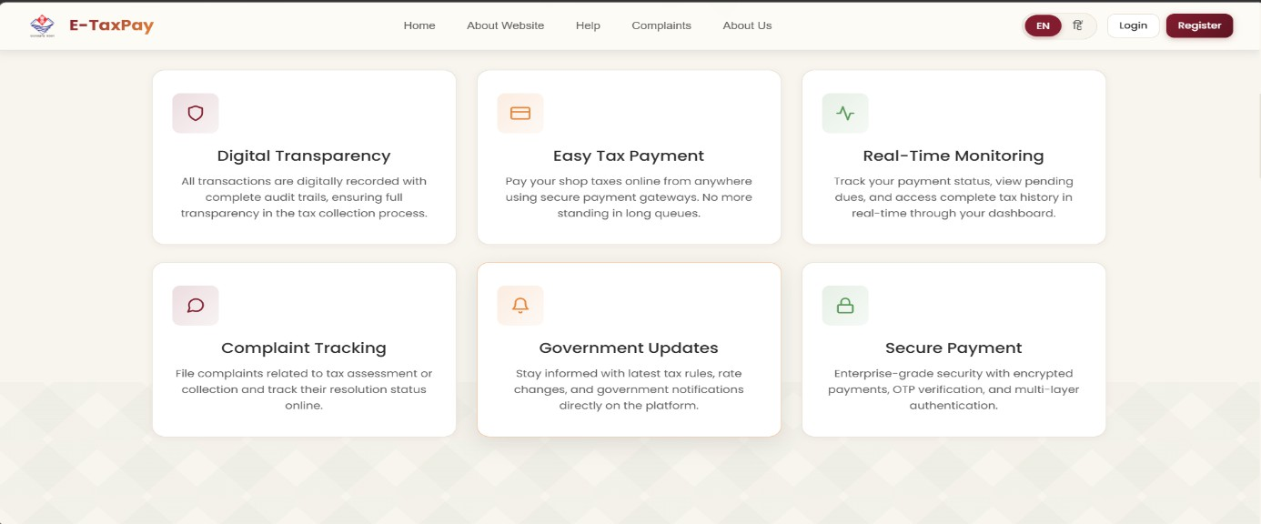

Backend Development
Along with the frontend development, the backend environment of the project has also been established using Node.js and Express.js. The backend is responsible for managing server-side operations, processing user requests, and communicating with the database.
The team has created the basic backend architecture, including API routes and middleware functions. These components allow the application to handle different operations such as user authentication, data validation, and request processing.
The backend structure has been organized in a modular way so that additional features such as payment processing, notification services, and complaint handling can be added easily in the next stages of development.
Another important improvement during the development process was related to the payment calculation logic. In the initial demo version of the system, the payment calculation logic was implemented in the frontend for quick testing. However, this approach was not secure because frontend code can be manipulated by users.
To solve this issue, the team has moved the payment calculation logic to the backend server, where all calculations are now performed securely. This ensures better protection of financial data and prevents unauthorized manipulation of payment values.

Database Design and Integration
A major milestone in the mid-term stage of the project was the design and implementation of the database schema. The team created a structured SQL schema that defines the tables and relationships required for storing system data.
The database structure includes tables for:
- Users
- Admins
- Tax records
- Payments
- Notices
- Complaints
- Notifications
The project is currently connected to a Supabase database environment, which provides a reliable platform for storing and managing application data.
Previously, during the frontend development phase, user information and other data were stored using mock data on the frontend. However, the system has now been successfully connected to the Supabase database, allowing real data to be stored and retrieved from the database.
At the current stage, the user panel has been integrated with the real database, while the admin panel is still using mock data. The integration of admin data with the database is currently under development and will be completed in the next phase of the project.

Payment System
Another important feature implemented during this stage is the dummy payment system. This system simulates the process of online tax payment for demonstration purposes.
The dummy payment system allows users to perform test transactions and observe how the payment process will function in the final system. It demonstrates features such as:
- Payment request
- Transaction confirmation
- Payment status update

Although the current system uses simulated payments, the architecture has been designed to allow easy integration of a real payment gateway such as Razorpay or Stripe in the future.

Current Development Status
At the mid-term stage, the project has successfully achieved the following milestones:
- Development of the frontend user interface using React and Tailwind CSS
- Creation of the backend environment using Node.js and Express.js
- Implementation of API routes and middleware
- Design of the SQL database schema
- Integration of the system with the Supabase database
- Implementation of a dummy payment system for demonstration
- Migration of payment calculation logic from frontend to backend for better security
These developments provide a strong foundation for the remaining features of the project.

Challenges Faced
During the development of the project, the team faced several technical challenges. One of the main challenges was transitioning from mock data to a real database environment. This required restructuring parts of the frontend and backend logic.
Another challenge was ensuring that the payment calculation logic was implemented securely. Moving the calculation logic to the backend required modifications to the API structure and server-side processing.
The team also faced challenges in managing data flow between frontend, backend, and database systems, which required careful planning and testing.

Future Development Plan
In the next phase of development, the team will focus on completing the remaining core features of the system. These include:
- Integrating admin panel data with the real database

- Implementing secure authentication and authorization systems
- Integrating a real online payment gateway

Adding tax analytics dashboards and reports
- Implementing the complaint management system
- Generating automatic notices and PDF receipts

Adding SMS and notification services
After completing the web platform successfully, the team also plans to develop a mobile application version of the system to make the platform more accessible to users.

Conclusion
The E-TaxPay project has made significant progress during the mid-term development phase. The team has successfully developed the main frontend interface, established the backend server architecture, and integrated the system with a real database environment.
Although some components such as admin database integration and real payment gateway implementation are still in progress, the foundation of the system has been successfully completed. With the remaining development work, the project is expected to evolve into a fully functional digital tax management platform for Zila Panchayat authorities and shop owners.

